Using Visual, Block-Based, Event-Driven Language to Teach Coding Skills

Samuel Groom, Asho Issak, Johnson Ngao, Taylor Williams

Dr. Anca Doloc-Mihu & Dr. Cindy Robertson

Abstract

The study target for this program is non-tech people. Our focus is to expose how technology works and how fun it is to learn create something using technology. The purpose of this study is to introduce these non-tech people to technology and the capabilities of hardware and show off what can be done in programming through the Scratch technology.

TAP is a program that offers students opportunities to learn more about technology, and help them develop creativity, leadership, communication, and teamwork skills. It also gives them the opportunity to do outreach with their projects so that non-tech people can get interested in technologies. The outreach will help TAP students build their leadership skills and make them gain public speaking confidence. Some of our outreach activities are the TAP Expo and in-class workshops.

There were 2 different types of technology used: Scratch (an interactive programming language that allows users to create interactive stories, games, and animations) and MaKey MaKey Classic (a circuit board that allows you to create a computer keyboard out of anything). We are trying to teach the students coding skills using “if-statements”, “while loops” and building blocks with Scratch. The coding structure will show the students how certain actions can be executed based on certain decisions.

For the TAP Expo, we are going to be developing projects with unique setups, so that GGC students can participate and have fun with it. For the in-class workshops, we are going to have the students fill out survey forms and get them involved in the project by making them participate.

In conclusion, we will successfully be able to teach our target audience the importance of learning new coding skills, and we will able to demonstrate how using technology can be fun.

# Introduction

Regarding related work, in Software Development 2, my team and I transferred an application that was originally written in basic HTML/JavaScript into React.JS. The application was a counter system for Magic the Gathering card game. It was designed to track health points, and other counters. In Software Development 1, my team and I created a text-based adventure game from scratch.

TAP

The Technology Ambassadors Program is a program that offers students opportunities to learn more about technology, and help them develop creativity, leadership, communication, and teamwork skills. It also gives them the opportunity to do outreach with their projects so that children of all ages can get interested in different technologies. The outreach will help TAP students build their leadership skills and make them gain public speaking confidence.

# Methods

We used Scratch and MaKey MaKey Classic in our project. Scratch is an interactive programming language that allows users to create interactive stories, games, and animations. MaKey MaKey is an academic and artistic project. The Classic version of MaKey MaKey is a circuit board that allows you to create a computer keyboard out of anything. We are trying to teach the students coding skills using “if-statements”, “while loops” and building blocks with Scratch. The coding structure will show the students how certain actions can be executed based on certain decisions. They will also use MaKey MaKey as well.

We will conduct outreach events of many kinds. The TAP Expo is an event where everyone demonstrates their finished projects to the entire college. Super Saturday Series (also known as S3) is where middle school and high school girls come to learn about technology. The girls would watch a demonstration of the finished project and then create their own version. The classroom event is where we would go to the “Introduction to ITEC” classes and present our project to the students. Afterwards, they would create their own version of our project. At the Workshop Research Symposium and Conference, we will be demonstrating our project to other students and teachers throughout the college. For each event, we will have a pre-survey and a post-survey for the students to fill out. The data collected from the surveys will help us make any changes to the way we present information.

What Are We Teaching

We conducted Outreach by doing online workshops due to the COVID-19. We presented our game to GGC Digital Media students through Blackboard Collaborate, a technology that allows users to conduct online training. We also did the TAP Expo Event through online using Zoom. We had over forty-five students attend our event.

TAP Expo

We had more than forty-five GGC students attend our online event. We presented our game and showed them how to make changes to the game, how it works and the technology we used.

Class Workshop

We held 4 online class workshops. We involved students in the workshops by doing a step by step walkthrough of how to make changes to the game. We also gave them copies of the game so that they could make their own changes into it. Eight students have actually made changes to the game and reached back to us.

# Results

Class Workshops

During the classroom workshops, we surveyed students on their programming knowledge and understanding. The survey involved 72 participating students where only 10% of them were ITEC majors. We asked if they had ever heard of “if-else statements” and “while-loops” before. 60 of the students provided feedback on how much they knew these programming skills before and after the workshops.

40 of them somehow knew or didn’t know at all an ‘if-else statement’, whereas, 47 of them somehow knew or didn’t know at all a ‘while-loop’ before the workshops. After the workshops, the number of students who completely understood ‘if-else statements’ and ‘while-loops’ grew to 49 and 45 respectively.

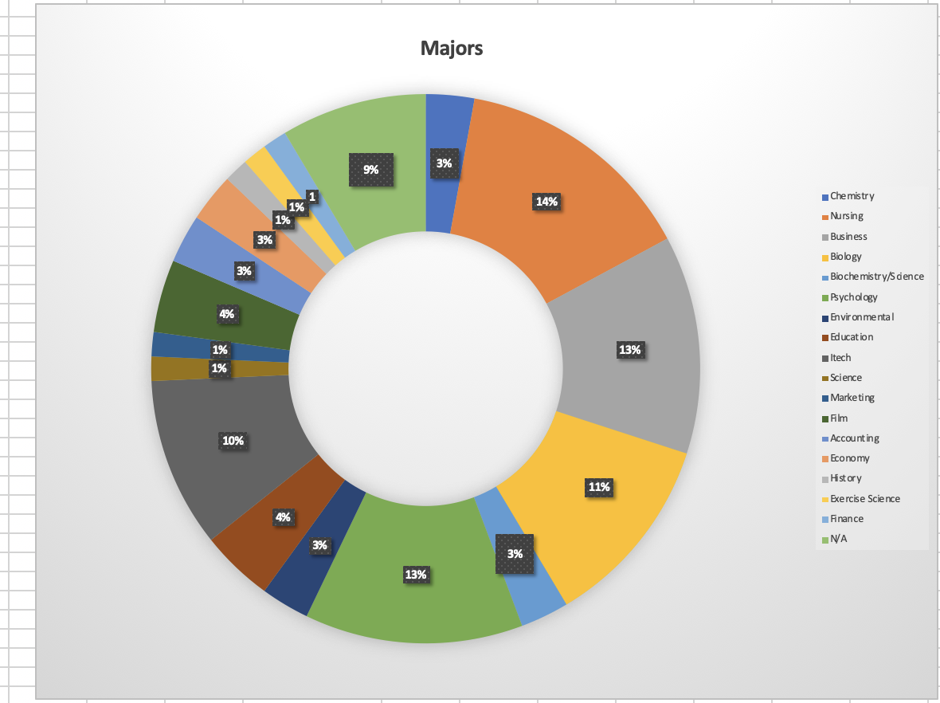

*Figure 1.* 10% of the students were Information Technology (ITEC) majors, while 90% of the students were not.

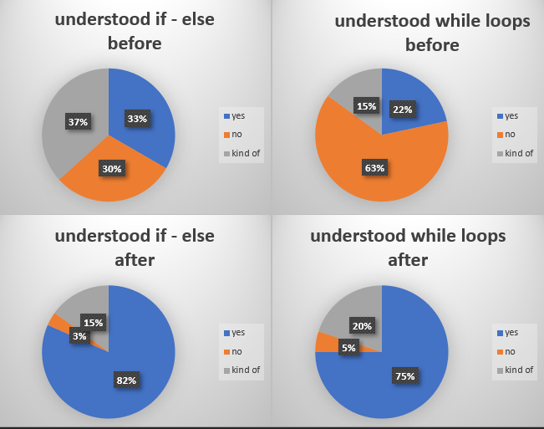

*Figure 2.* Results from the pre-survey and post-survey show there was a large increase in the percentage of students that did understand if-statements and while loops, while there was a large decrease in the percentage of students that did not understand if-statements and while loops.

Eight students from the workshop who were non-ITEC majors made changes to the pool game as a result of understanding if-else statements and while-loops. Of these eight students, three were Psychology majors, two were Biology majors, one was a History major, one was a Nursing major, and the other one did not have a specific major. Six of them fully understood these programming skills, while the other two partially understood them. They modified the size of the balls and the background of the game using the two programming skills: if-else statements and while-loops.

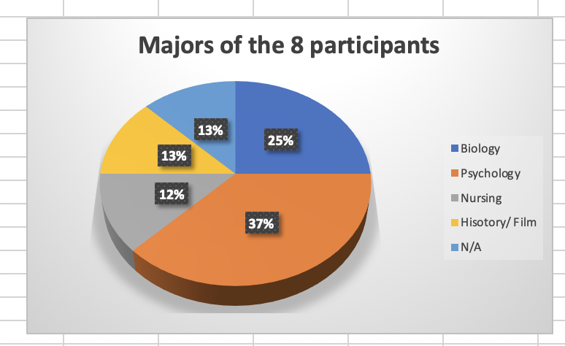

*Figure 3.* None of the participants that independently made changes to the game were ITEC majors.

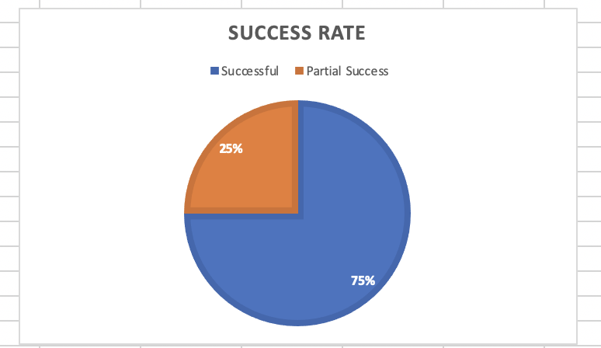

*Figure 4.* There was success with 75% of the students that independently made changes to the game, because they were able to make complex changes, while there was partial success with 25% of them, because they made simple changes.

# Discussion and Conclusion

Our project goal was to teach students two programming skills, if-else statements and while loops, using scratch programming language and a MaKey MaKey tool. Through TAP program, we conducted class workshops and a TAP Expo to achieve our project goal. However, we were not able to supply MaKey MaKey tools to students due to the COVID-19 pandemic. Thus, a couple of keyboard keys were used in place of a MaKey MaKey tool to teach students these programming skills.

TAP helped us to successfully reach our project goal of teaching students if-else statements and while loops by giving us opportunities to conduct multiple class workshops and a TAP Expo. A good number of students who somehow knew or didn’t know at all if-else statements and while loops ended up understanding these programming skills fully by the end of the workshops and TAP Expo.

We were able to teach and make students understand these programming skills because TAP made us develop creativity, teamwork, leadership, communication skills and confidence.

# References

About Us, Learn About Makey Makey's Invention Kits - Makey Makey. (n.d.). Retrieved February 3, 2020, from <https://makeymakey.com/pages/about-us>

Resnick, M., Silverman, B., Kafai, Y., Maloney, J., Monroy-Hernández, A., Rusk, N., … Silver, J. (2009). Scratch: Programming for All. *Communications of the ACM*, *52*(11), 60–67. doi: 10.1145/1592761.1592779

# Acknowledgements

We would like to thank the MIT Media Lab for creating the MaKey MaKey circuit board and the Scratch programming language. We would also like to thank the GGC TAP committee for always being there for us whenever we needed them, the STARS Computing Corps, and GGC’s School of Science and Technology for making this opportunity possible for us.